***DESARROLLO DE SOFTWERA***

***Base de datos cursos***

Ing. Yolanda Moya

Nombre: Jhonathan chiliquinga

Curso: 2”A”

select * from asistente where idcurso_edicion = 2

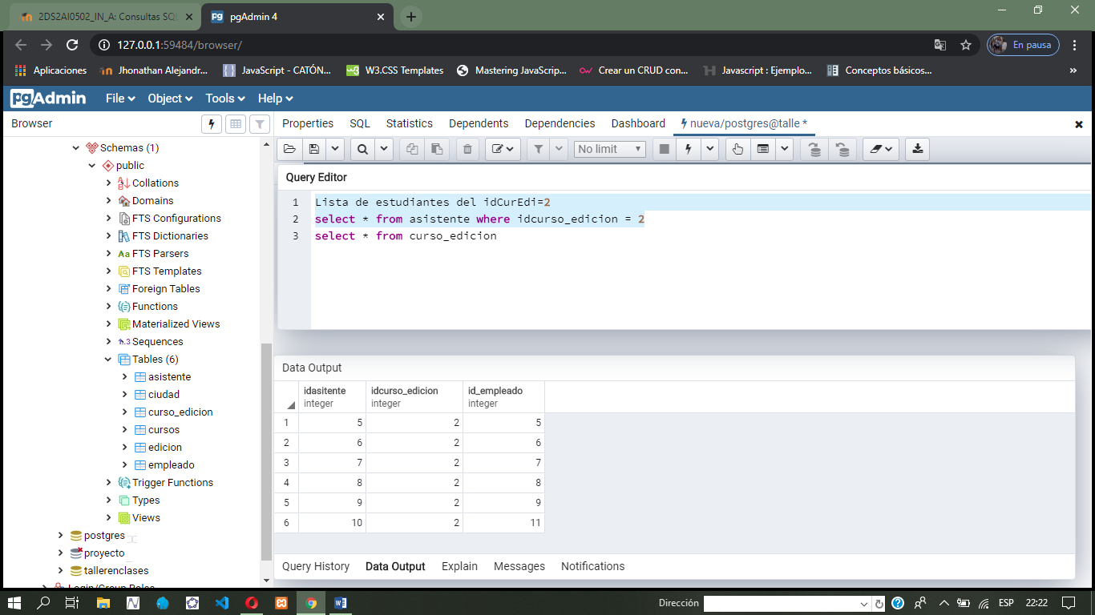

select e.nombre, r.idcurso_edicion ,f.id_curso

from empleado as e, curso_edicion as r, cursos as f

where e.id_empleado = r.idcurso_edicion and f.id_curso = 2

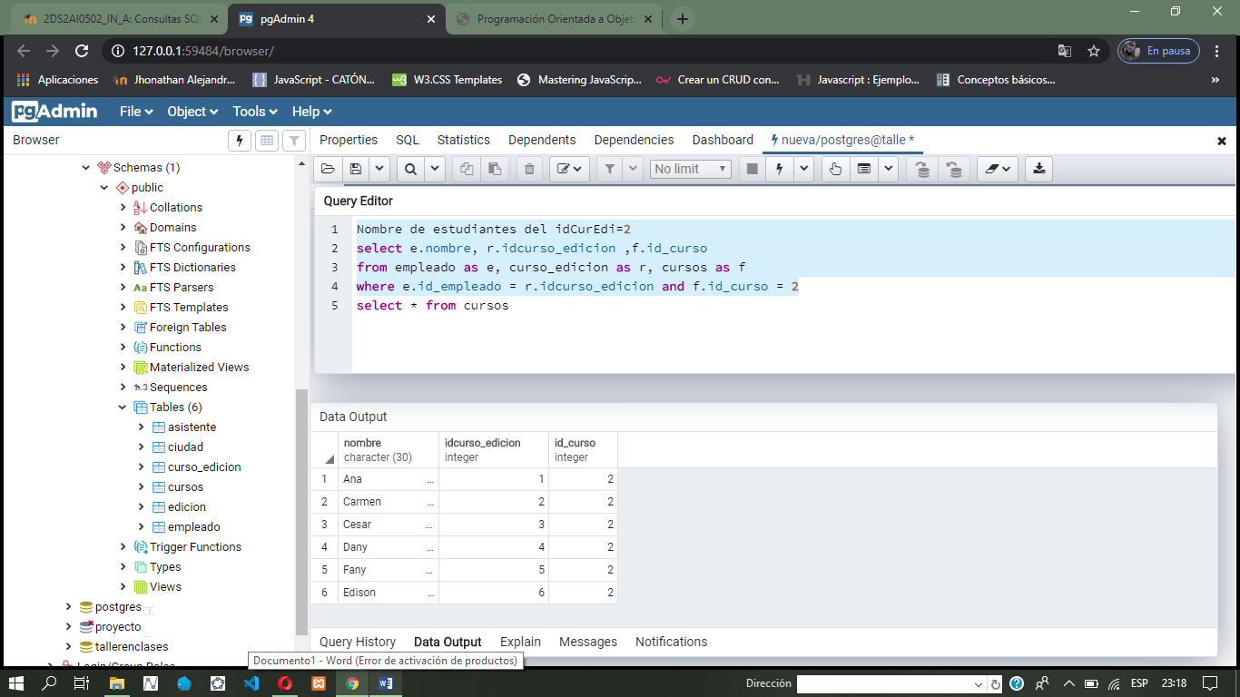

select d.id_empleado, g.id_curso

from empleado as d, cursos as g

where d.id_empleado = g.id_curso

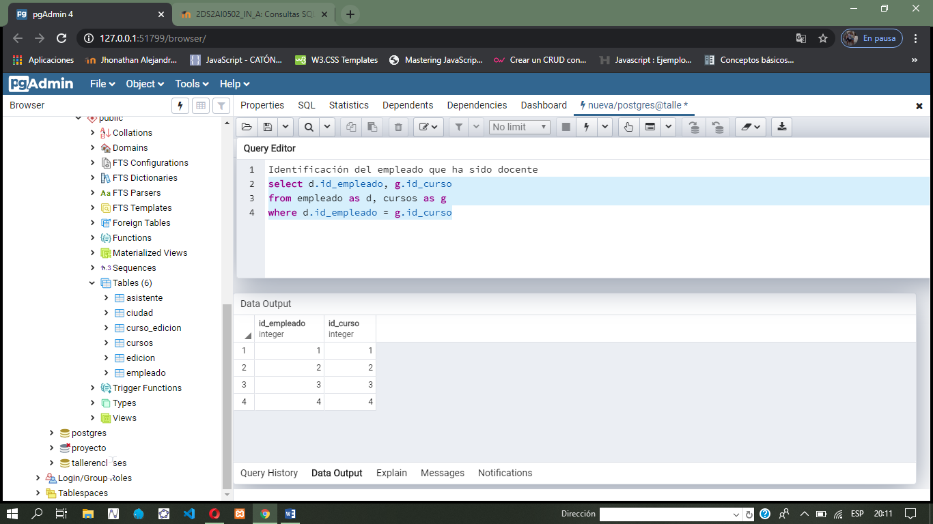

select d.nombre, g.id_curso, t.id_edicion

from empleado as d, cursos as g , edicion as t

where d.id_empleado = g.id_curso

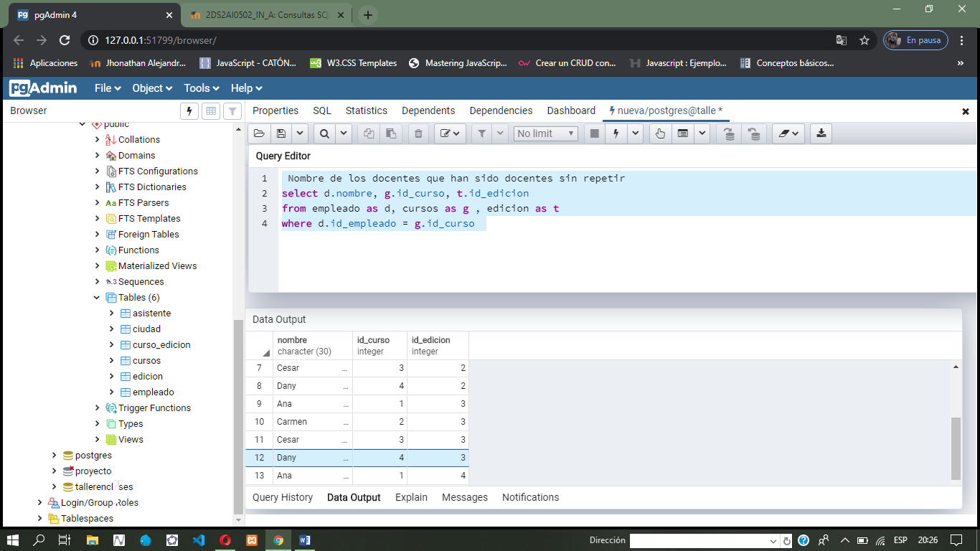

select j.idasitente, o.id_curso

from asistente as j, cursos as o

where j.idasitente = o.id_curso

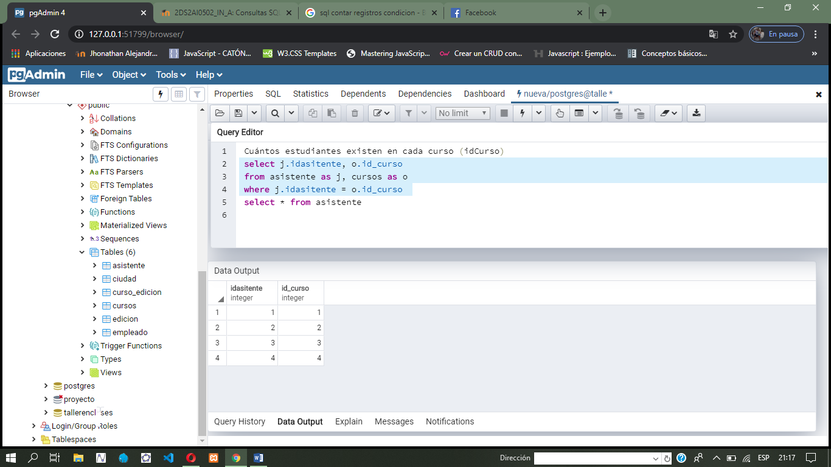

select m.nombre , x.id_curso

from empleado as m, cursos as x

where m.id_empleado = x.id_curso and id_curso = 3

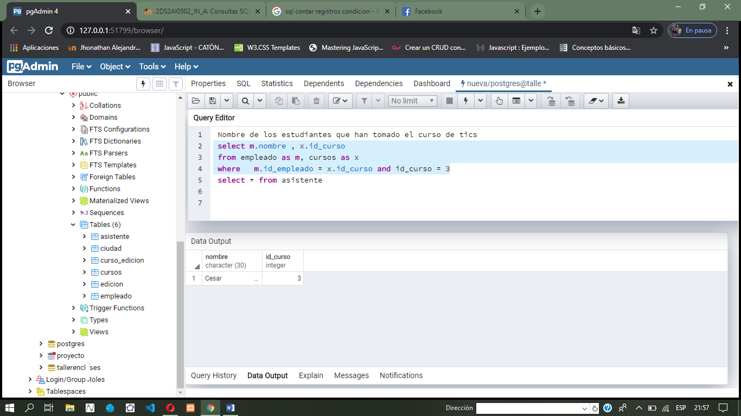

select c.nombre, d.id_edicion

from ciudad as c, edicion as d

where c.id_ciudad = d.id_edicion and id_edicion = 3

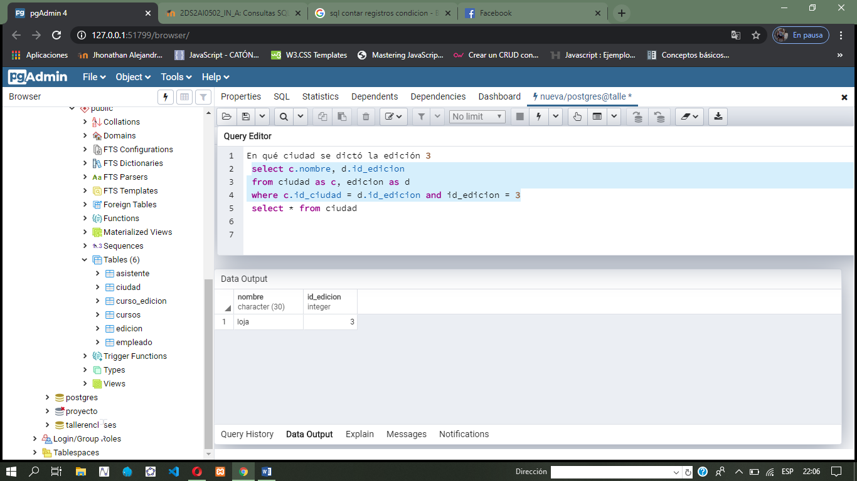

select c.nombre, d.id_edicion, w.id_curso

from empleado as c, edicion as d, cursos as w

where c.id_empleado = w.id_curso and id_edicion = 1

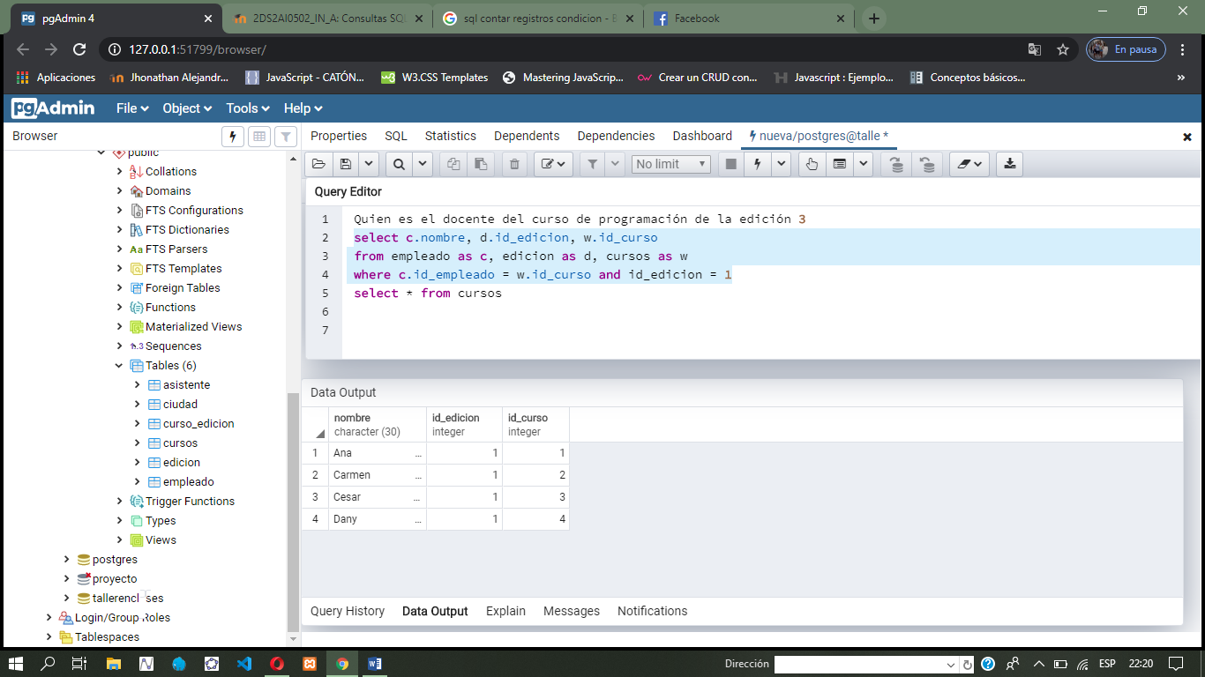

select c.nombre,c.apellido, d.id_edicion, w.nombre

from empleado as c, edicion as d, cursos as w

where c.id_empleado = w.id_curso and id_edicion = 2

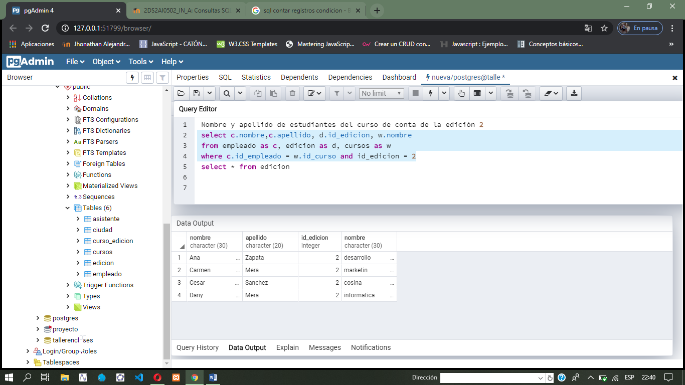

select s.nombre, s.costo_curso, s.num_hora, g.id_edicion

from cursos as s,edicion as g

where s.id_curso = g.id_edicion

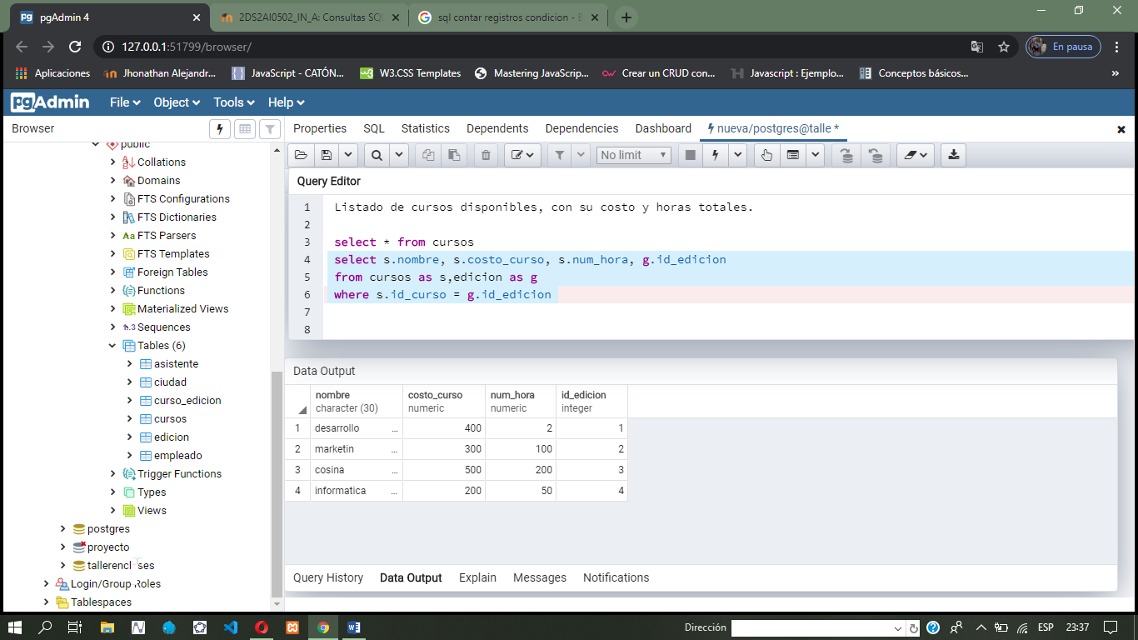

select * from empleado where nombre like 'A%'

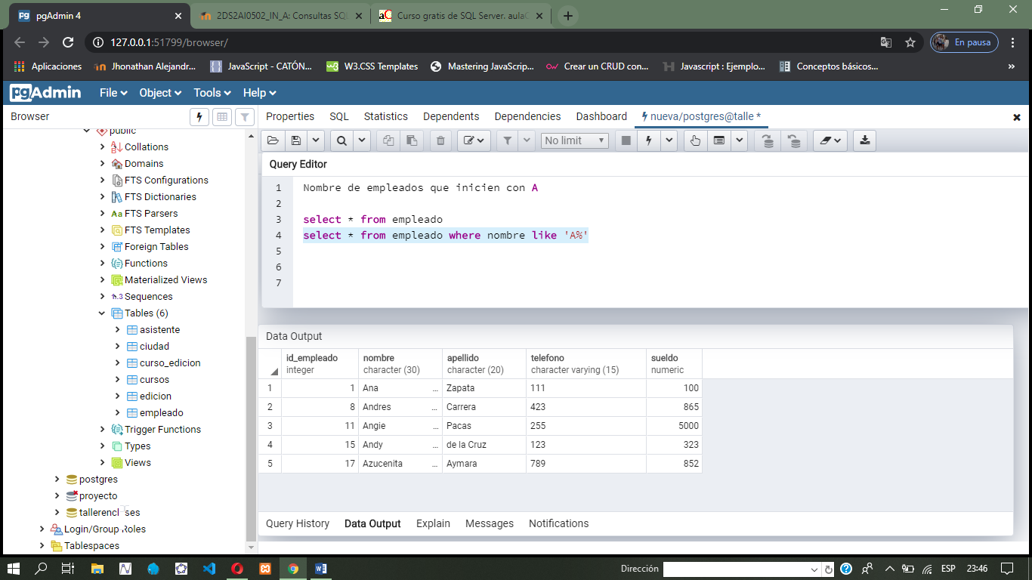

select * from empleado where apellido like '%s'

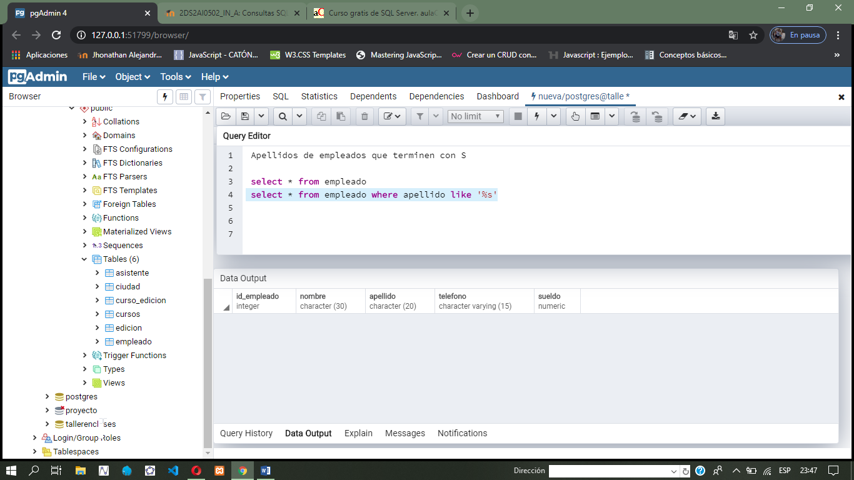

select apellido from empleado where apellido like 'Z%'

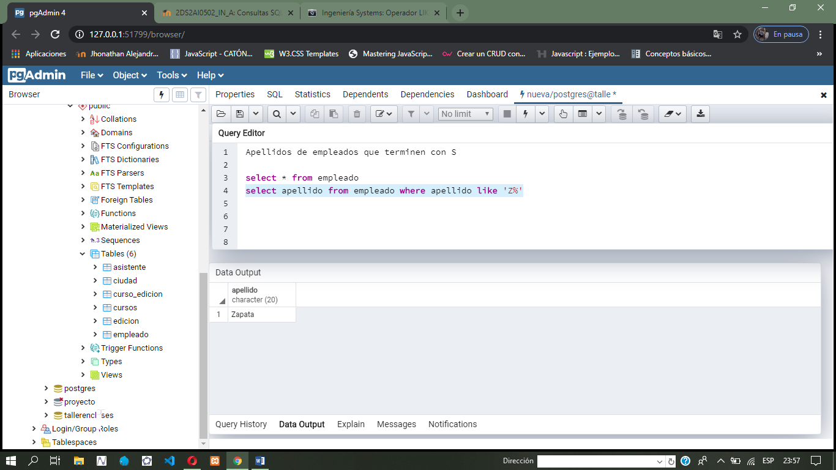

select * from empleado where sueldo=400

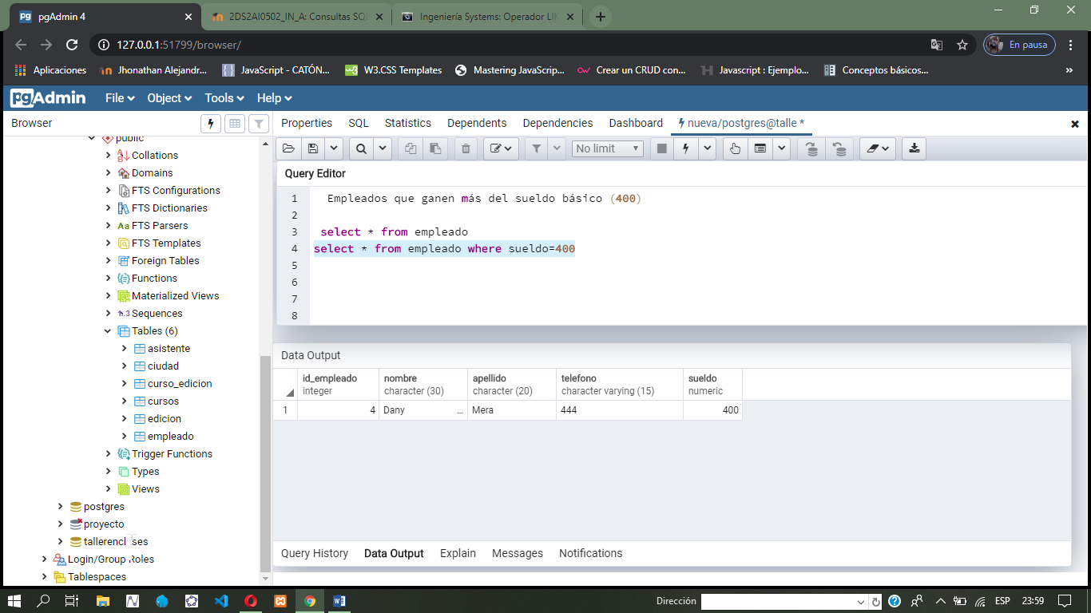

select * from empleado where apellido like 'S%' and sueldo=600

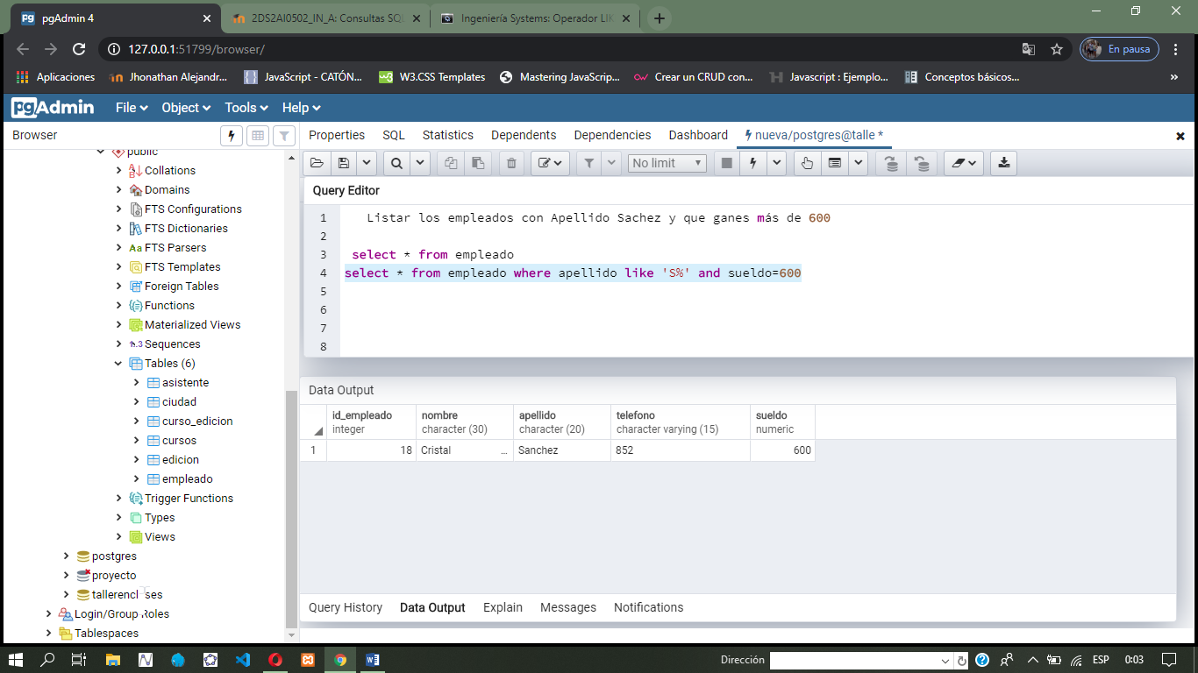

select * from empleado where nombre like 'A%'

select * from empleado

select * from empleado where apellido like 'S%'

select * from asistente where

select asistente , count (*)

from asistente group by asistente

select sum(sueldo ) from empleado where sueldo < 600

select max(sueldo) from empleado

select nombre, apellido, sueldo from empleado where sueldo between 500 and 700

select apellido, nombre, telefono from empleado where telefono in ('111','222','444','555')